LineageIQ — Canonical Lineage Model for AI-Generated Deterministic Parsers

We recommend establishing a versioned, technology-neutral Canonical Lineage Model (CLM) as a mandatory contract for every deterministic parser generated by LineageIQ's AI agents.
The model should support Teradata BTEQ, Informatica, Ab Initio, Hive, Oracle, SQL Server, Python, Java, BigQuery, and orchestration technologies such as Autosys.
The key architectural principle is:
AI generates parser code. The deterministic parser extracts lineage. The canonical model standardizes its output. A validation engine verifies the results.

- Recommended architecture

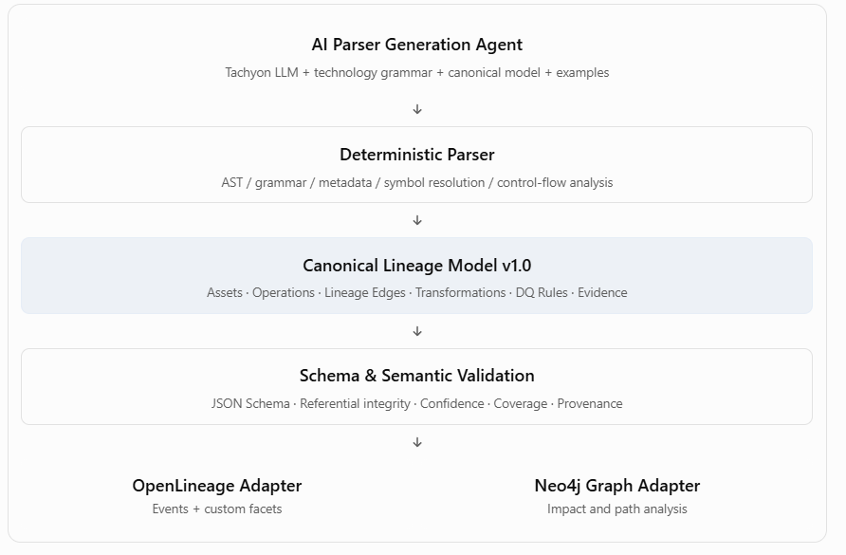

2. Canonical model structure
Entity | Purpose | Key attributes
SourceArtifact | Original code or metadata | URI, version, hash, language
DataAsset | Table, file, topic, API, view | Platform, namespace, name
DataElement | Column or nested field | Parent asset, path, data type
Operation | Executable processing step | Type, inputs, outputs, execution order
LineageEdge | Source-to-target relationship | Source, target, operation, relationship
Transformation | Field-level transformation logic | Expression, function, mapping
DQRule | Data-quality constraint | Scope, dimension, predicate, severity
SystemCheck | Operational validation | Dependency, freshness, counts, status
ControlFlow | Conditional execution and dependencies | Branch, loop, trigger
Evidence | Proof of extracted lineage | File, line, column, parser rule
ResolutionIssue | Unresolved dynamic references | Symbol, reason, candidate values

3. Canonical JSON contract
The following is a representative canonical output payload. All generated parsers should produce this structure, with arrays empty when no entities are found.
For production, this JSON contract should be enforced through a formal JSON Schema with required fields, enums, referential integrity checks, and version compatibility rules.

4. Standard transformation taxonomy
Every parser should use the same transformation vocabulary.
Transformation | Example
DIRECT | TARGET_ID = SOURCE_ID
DERIVED | TOTAL = PRICE * QUANTITY
AGGREGATION | SUM(AMOUNT)
FILTER | WHERE STATUS = 'ACTIVE'
JOIN | A.ID = B.ID
LOOKUP | Reference-table lookup
CONSTANT | STATUS = 'NEW'
CAST | CAST(ID AS VARCHAR)
MASKING | MASK(SSN)
HASHING | SHA256(CUSTOMER_ID)
CONDITIONAL | CASE WHEN ...
WINDOW | ROW_NUMBER() OVER (...)
UNION | UNION ALL
UNKNOWN | Unsupported or unresolved logic

A transformation may contain multiple inputs. The model must distinguish value dependencies from filter, join, grouping, and control dependencies so downstream impact analysis does not treat every referenced column as a direct contributor to the output value.

5. DQ and system-level checks
The model should treat data quality as first-class metadata rather than merely descriptive annotations.

Recommended DQ dimensions include completeness, uniqueness, validity, consistency, accuracy, integrity, and timeliness.
System checks should additionally support job return codes, dependency availability, source freshness, reconciliation, file arrival, schema compatibility, and SLA checks.
Important: A parser must only report checks supported by actual source evidence. It must never invent a DQ rule because it considers that rule good practice.
6. AI prompt template for generating deterministic parsers
This is the reusable instruction template I would provide to the LineageIQ parser-generation agent.
LINEAGEIQ PARSER GENERATION — SYSTEM PROMPT

7. Additional enterprise guardrails
For LineageIQ, I would enforce these architectural decisions:
- Canonical model ownership: A centralized schema registry owns all model versions. Individual parser teams cannot independently extend the core contract.
- Technology adapters: Each parser handles source-specific semantics, but emits the same normalized entities.
- Stable identity: IDs derive from normalized qualified names, scope, and source revision where appropriate—not random UUIDs for repeatable extracted objects.
- Evidence-first extraction: Every material lineage assertion must be traceable to source code or authoritative metadata.
- Confidence separation: Deterministically proven lineage, externally resolved lineage, and AI-suggested lineage must have distinct statuses. A numerical confidence score alone is insufficient.
- OpenLineage interoperability: Map supported canonical entities to OpenLineage datasets, jobs, runs, and facets; retain richer transformation, DQ, and unresolved-reference details in versioned custom facets or the canonical repository.
- Parser certification: Certify each parser against representative golden datasets, including dynamic SQL, temporary tables, error handling, conditional branches, and negative test cases.

8. Recommended next evolution
The JSON example above is the logical canonical model. Before using it as the production prompt contract, I recommend creating three additional specifications:
Artifact | Purpose
lineageiq-canonical.schema.json | Machine-enforceable JSON Schema with strict validation
lineageiq-parser-contract.md | Detailed semantic rules, identity conventions, lineage classifications, and technology-neutral requirements
lineageiq-golden-tests/ | Input scripts and expected canonical output for each supported technology

This separation is important: the AI prompt explains how to build the parser, while the canonical schema and golden tests objectively determine whether the generated parser is correct.
For LineageIQ, I would make the JSON Schema and semantic parser contract mandatory inputs to every Tachyon-based parser-generation workflow, with CI validation preventing unverified parser code from being deployed.

